

Instructions
It is important to understand that this document is the foundation (or blueprint) of your site. Please remember that each item is considered as an actual page with content, unless you tell us otherwise (for instance, an internal page anchor can denote an area on a page, but you do not wish an actual page).

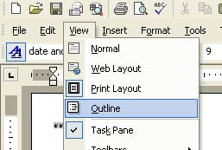

We find working in Microsoft Words <Outline View> to make the process easier and productive.

Please note: screen caps and directions were done in Office XP. Older versions of Office may look different. If you have trouble, let us know; we’ll walk you through!

At this point, click on Format in your menu bar,
then on Styles and Formatting.
Your Formatting Group should be now available on your right.

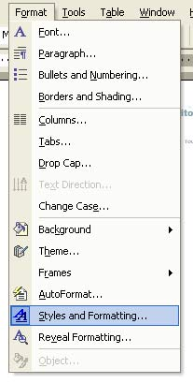

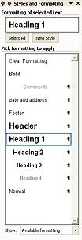

.



The next step is to add the pages that you need. The Home page always starts first and is given a Heading 1.

Designating a Heading 1 can be done in one of two ways. Either by clicking on Header 1 in the Styles and Formatting Box, or by using the Outlining Tool pictured below.

If you do not see the Outlining Tool Bar, click on View, in your menu bar, then Toolbars then Outlining. Or, right mouse click on the menu bar and choose Outlining. You can use either the first drop down or the left or right arrows.

Proceed with the other pages giving them a Header 2 or 3, 4, 5 etc. if these pages are underneath another page as follows.

Home (Heading 1)

Product Page (Heading 2)

Product A (Heading 3)

Tech specs (Heading 4)

Please try to use the styles and formats we have provided you. It makes things a lot easier in the long run. Understand that each Heading item you put down will be a page with content, built out with navigational links, unless you tell us other wise. For example, you have an area called Products, but that will not be a page. People will be able to click on the particular product directly via a drop down navigation schema or some other means.

Use the comments style for indicating to us this type of comment and for indicating functional needs like forms, password protection, database hookup, or other script related issues. We are not looking for the actual text or a comment on this text, such as, “this page will have info about our products and links to the other pages”. Yet, we are interested to know if the page will feature a long and/or complex form, animation of some item, etc. Again, special needs.

When you have completed the list, you can use the Outlining Tool to show or hide various levels by using the Show Levels drop down to the right of the Up Down arrows. This can give a person a feel of navigation if your site has three or more levels.

On the next page, we have started on for you as a guide. If you are stuck, please let us know and we will help. If your site is a bigger site, you may wish to consult us about Architecture Development.

Thanks and Good Luck!

Site Map for (your company)

Company Name: Enter Company Name Here...

Your Name: Your Name Date:

Home Page
It is important to keep comments as this comment text is.
Use the styles, not the format bar!

Product Page
Is this an area, or a real page?

Product A

Tech specs

Product B

Tech specs

Product C

Tech specs

Our Services

About Us

Contact Us
Will you need a contact form? Are there any special requests for this form?

Directions

